Qn no.1: Design and implement a secure firewall policy for a university campusnetwork by defining appropriate access-control rules, segmenting networkresources, controlling inter-department communication, and evaluating theeffectiveness of the implemented security policy through connectivity andsecurity testing.

AIM
To design and implement a secure firewall policy for a university campus network using Cisco Packet Tracer by segmenting network resources, controlling inter-department communication using access-control rules, and testing the effectiveness of the security policy.

APPARATUS / SOFTWARE REQUIRED
- Cisco Packet Tracer
- Router
- Layer 2 Switch
- PC-PT devices
- Printer-PT devices
- Ethernet cables

OBJECTIVES
- To design a secure university campus network.
- To divide the network into separate departmental segments.
- To assign appropriate IP addresses to network devices.
- To configure routing between different network segments.
- To control inter-department communication using Access Control Lists (ACLs).
- To allow authorized communication and block unauthorized access.
- To verify the firewall policy through connectivity and security testing.

PROCEDURE
- Open Cisco Packet Tracer and create the university campus network topology using a router, switch, PCs, and printers.
- Connect the PCs and printers to the switch using Ethernet cables.
- Connect the router to the switch.
- Assign IP addresses to the devices according to their respective network segments.
- Configure the router interfaces and required routing for communication between the networks.
- Configure the required VLAN/network segmentation for different departments.
- Configure Access Control Lists (ACLs) on the router to control communication between departments.
- Allow required communication between authorized networks and block unauthorized communication.
- Test connectivity between the network devices using ping or Packet Tracer simulation tools.
- Verify that allowed traffic is successful and restricted traffic is blocked.
- Observe the packet flow using Simulation Mode and record the results.
OUTPUT
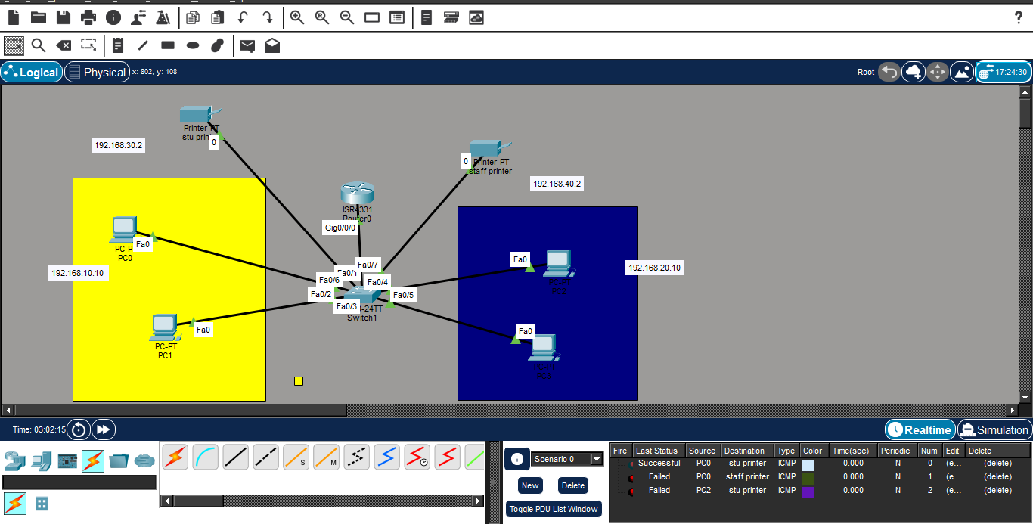

RESULT
The secure university campus network was successfully designed and simulated using Cisco Packet Tracer. Network segmentation and access-control rules were implemented to control communication between different departments. Connectivity and security testing were performed to verify the effectiveness of the firewall policy.

